Code -> github-> GitHub Actions → GHCR → Cloud Run
Project implementation:
1. Wrote a API code with python – FASTAPI
2. Create a files for automation testing – test_main.py “from fastapi.testclient import TestClient”
3. Write a dockerfile and push to github
4. What comes next?
Local application and tests – done
Local Git commits – done
GitHub remote and push — current step
GitHub Actions — automate the tests
Docker — build and run the container
Google Cloud deployment
5. You’ve completed these steps:
- FastAPI application and automated tests - Done
- GitHub repository and version control - Done
- Dockerfile and local container execution - Done
- GitHub Actions running your tests - Done
- GitHub Actions building your Docker image – Done
- Next step: CD — Continuous Delivery – current step

2. Create a files for automation:
step1: create a file .pytest_cache folder and some files which mention the testcases
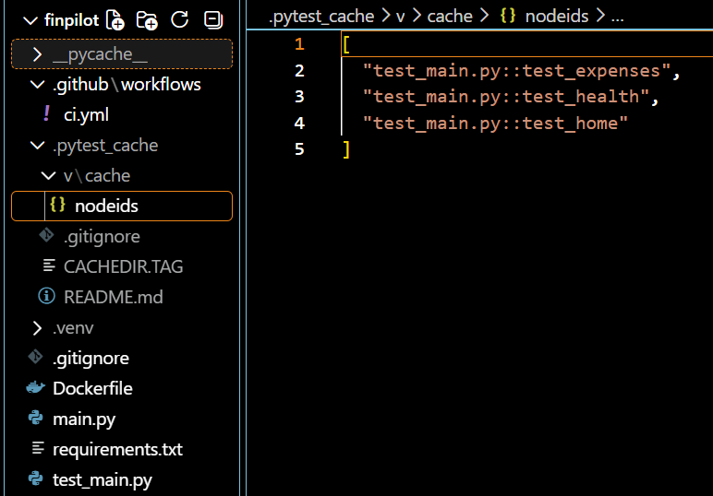
step2: create a test_main.py – which describes the test values and evaluations
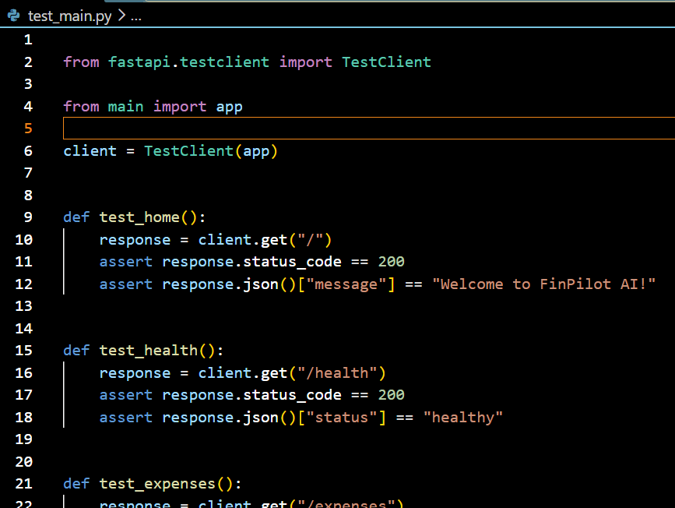

4. Create a CI – github actions:
step1: create for automate the test:
create a file “ci.yml” in this folder which is under the project folder : .github/workflows/ ci.yml
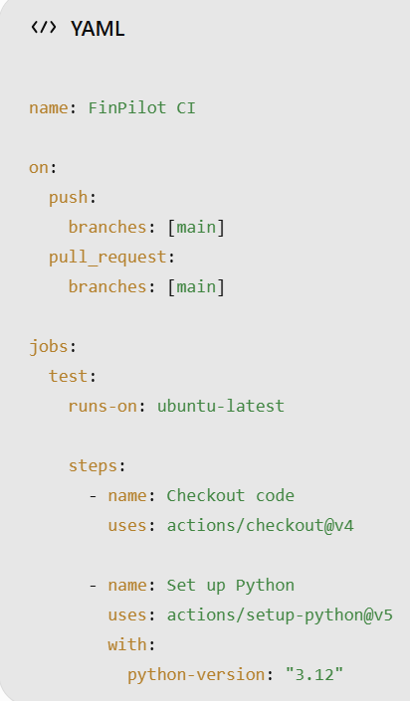 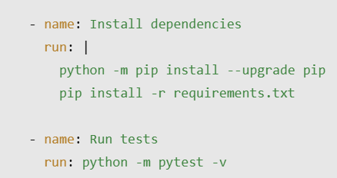
This workflow uses a GitHub-hosted Ubuntu runner. It checks out your code, installs Python and your dependencies, and runs your three existing tests.
Notes: First says the OS (where can use – here its using github-hosted ubuntu runner) then it will install the python and dependencies of the application then run the tests.
- Push this code to github and open that repo’s action page, you can see the actions and see the testcases – pass/ fail
Step2: create for automate the docker image build
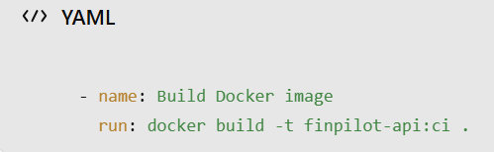 add in ci.yml for docker image auto build
Understand what you have achieved
Your pipeline now checks both your application code and its container build whenever you push changes to main.
Note: this builds the image on GitHub's temporary runner. It does not upload the image to Docker Hub or deploy your application yet.
5. Next step: CD — Continuous Delivery
- publish your Docker image to GitHub Container Registry (GHCR) - This gives your image a place to live online, so a server or cloud platform can pull and run it without rebuilding it from your source code.
GitHub documents this workflow using GITHUB_TOKEN and the packages: write permission, so you don't need to create a separate password or token for this pipeline
Step 1: Replace your workflow with this version
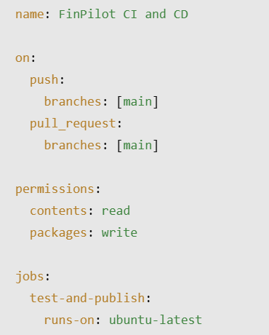…..same as existing, and add the below codes in the end.. 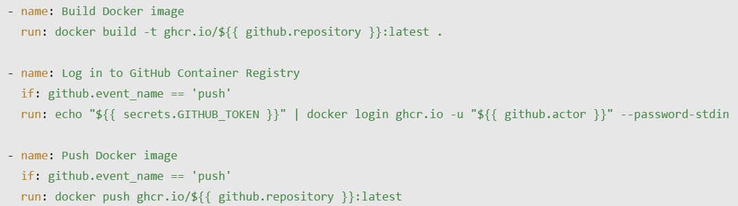

Once done, push to github and you can see the every stages in actions and once everything is done you can see the latest image in packages of your github page https://github.com/malarvizhi-palanisamy
WE done : CI + Docker + Container Registry.

Step2: Deploy FinPilot to the cloud
Before deployment, need to verify whether the github published image – can pull into our local , inside the package we can get the imges’ pull request url -? Do this command in the vs code and run,once its successfully pulled its ready for the deployment.
What you have achieved
1. GitHub Actions — CI - Done
Your workflow runs automated tests and builds the Docker image.
2. GHCR — Image publishing -Done
Your workflow publishes the image to GitHub Container Registry.
3. Docker pull — Verified -Done
Your computer successfully downloaded the published image.
4. Cloud deployment — Next
Deploy FinPilot so it can run online without depending on your laptop.
Cloud run – GCP - It can run your Docker container without requiring you to manage a virtual machine or Kubernetes cluster.

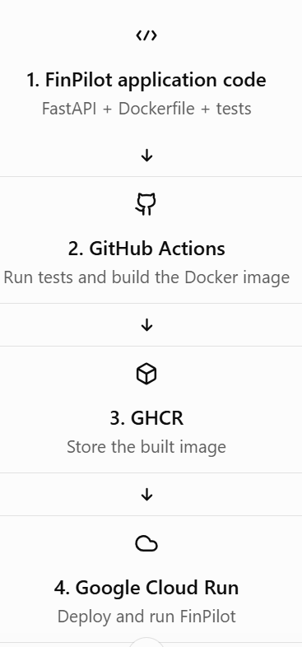
step1: create a service in the cloud run with container image – paste the GHCR url and the docker port (8000) should be match with the cloud run service port (8000)
- fill all the necessary fields
Now the automatic CI was enabled (once edit the code and push to the github it will automatically build the image and push to GHCR)
Next create a CD pipeline -> auto deploy to cloud run
Why does GitHub Actions need authentication?
Your GitHub Actions workflow runs on GitHub's computers, but your FinPilot service belongs to your Google Cloud project.
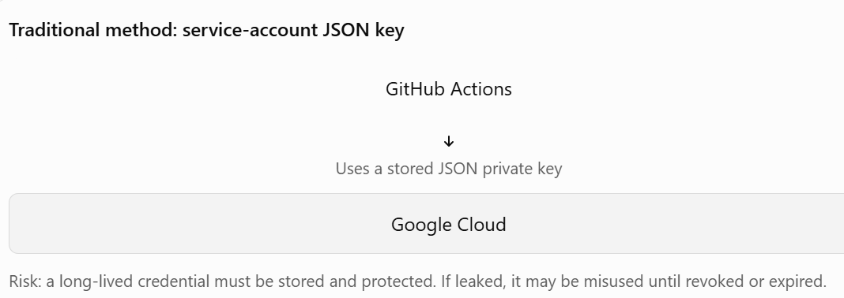
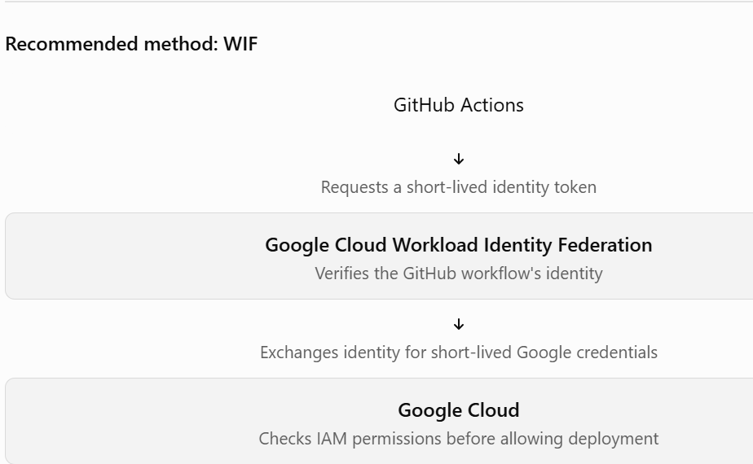
Workload identify manager will gives the external identity to connect with the google cloud .
Important: two different identities
Identity | Purpose
GitHub Actions identity | Proves which workflow is requesting access
Deployment service account | Provides Google Cloud permissions to deploy the service
Cloud Run runtime service account | Gives your running FinPilot application access to Google Cloud resources
How does Google know it's your GitHub repository?
We configure a trust relationship between GitHub and Google Cloud.
For FinPilot, the setup will look like this:
- GitHub repository: malarvizhi-palanisamy/finpilot
- Workload Identity Pool: A Google Cloud resource that groups trusted external identities.
- Workload Identity Provider: Configures how Google trusts GitHub's identity tokens.
- IAM permissions: Restrict which repository or workflow can use that trust and what it can do.
- Deployment service account: The Google Cloud identity used by the workflow to deploy to Cloud Run.
We can restrict trust to your specific repository rather than allowing any GitHub repository to deploy.

Interview-ready answer
“Workload Identity Federation allows GitHub Actions to authenticate to Google Cloud using trusted external identity tokens. Google validates the token, and the workflow obtains short-lived credentials to access permitted resources. This avoids storing long-lived service-account JSON keys in GitHub secrets and supports least-privilege access through IAM.”
Step1: select the project on the top – which is created cloud run – respective application
Step 2 — Enable the required Google Cloud APIs
We need these APIs for GitHub Actions to authenticate and deploy your FinPilot container:
- IAM Service Account Credentials API — supports short-lived credentials.
- Security Token Service API — exchanges the GitHub identity token for Google credentials.
- Cloud Resource Manager API — helps manage and reference project resources.
- Cloud Run Admin API — manages Cloud Run services and deployments.
- Artifact Registry API — useful if we later move your images from GHCR to Google Artifact Registry.
Do this now
Open the Google Cloud APIs Library.
Step3: Create a deployment service account
This service account will give GitHub Actions permission to deploy FinPilot to Cloud Run. It is not the same as the service account used by your running application.
Follow these steps
- Open Service Accounts in your project.
- Confirm the selected project is devops-project1-512907.
- Click Create service account.
- Enter:
- Service account name: github-actions-deployer
- Service account ID: let Google generate it from the name
- Description: Allows GitHub Actions to deploy FinPilot to Cloud Run using Workload Identity Federation
5. Click Create and continue.
Step 4 — Grant the deployment permissions
Now we'll give this service account permission to deploy your FinPilot container to Cloud Run.
We need two roles for this setup:
- Cloud Run Admin — allows the workflow to create and update Cloud Run services and revisions.
- Service Account User — allows the workflow to deploy Cloud Run using the runtime service account assigned to the service.
For a learning project, we'll grant these at the project level first, then we can tighten permissions later.
Follow these steps
- Open IAM for your project.
- Click Grant access.
- In New principals, enter:
github-actions-deployer@devops-project1-512907.iam.gserviceaccount.com
- Add the role Cloud Run Admin.
- Click Add another role and add Service Account User (roles/iam.serviceAccountUser).
- Click Save.
Don't add Owner or Editor.
Important: This service account is for deployment. We still need to configure Workload Identity Federation to let only your intended GitHub repository use it.
Tell me when both roles are saved.
Step 5 — Create a Workload Identity Pool
Do this now
- Open the Workload Identity Pools page.
- Confirm the project is devops-project1-512907.
- Click Create pool.
- Enter these values:
- Name: github-actions-pool
- Pool ID: github-actions-pool
- Description: Trust pool for FinPilot GitHub Actions deployments
5. Click Continue or Create, depending on the screen.
Select the provider type
On the Select a provider screen:
- Look for OpenID Connect (OIDC).
- Select it.
- Click Next or Continue.
Why OIDC? GitHub Actions can issue a short-lived identity token for a workflow. Google verifies that token through this provider instead of requiring a permanent JSON key.
Our trust will be restricted to your repository:
malarvizhi-palanisamy/finpilot
After you select OIDC, tell me which configuration fields appear. We'll fill in the issuer URL, audience, and repository restrictions carefully.
Step 5B — Enter these values
Field | Value
Provider name | GitHub Actions
Provider ID | github
Issuer URL | https://token.actions.githubusercontent.com
JWK file (JSON) | Leave empty
Audiences | Keep Default audience selected
Allowed audiences | Leave empty
Why these values?
- Issuer URL: GitHub's official OIDC identity provider.
- Provider ID: github — this becomes part of the provider's resource name.
- JWK file: Not needed because Google can obtain GitHub's public signing keys.
- Default audience: We'll configure GitHub Actions to request the matching audience when it obtains its token.
Step 5C — Configure provider attributes
Enter these mappings in the table.
Google 1 — Google attribute | OIDC 1 — OIDC attribute
google.subject | assertion.sub
attribute.repository | assertion.repository
attribute.repository_owner | assertion.repository_owner
Use Add mapping to add the two additional rows if needed.
Configure the attribute condition
In the Attribute conditions field, enter:
assertion.repository == 'malarvizhi-palanisamy/finpilot'
This condition means only tokens identifying that exact GitHub repository can authenticate through this provider. It prevents other repositories from using this trust relationship.
Why are we doing this?
- assertion.sub identifies the GitHub workflow subject.
- assertion.repository identifies the repository that issued the token.
- The condition restricts authentication to your FinPilot repository.
Step 6 — Allow the GitHub identity to use your deployment service account
Creating the pool and provider establishes trust, but we still need to connect that trust to the github-actions-deployer service account.
Do this now
- Open Service Accounts.
- Find and click github-actions-deployer.
- Open the Permissions tab.
- Click Grant access (or the equivalent option to grant a principal access to this service account).
- Add this principal, replacing PROJECT_NUMBER with your numeric project number, which the console showed as 625484093154:
principalSet://iam.googleapis.com/projects/625484093154/locations/global/workloadIdentityPools/github-actions-pool/attribute.repository/malarvizhi-palanisamy/finpilot
6. Grant this role:
Workload Identity User (roles/iam.workloadIdentityUser)
7. Save.
What does this permission do? It allows the trusted GitHub repository identity to impersonate the deployment service account and obtain short-lived Google Cloud credentials. It does not grant every GitHub user unrestricted access to your Google Cloud project.
Step 7 — Update your workflow file
Replace the contents of your existing .github/workflows YAML file with this updated version. It retains your current CI steps and adds the Cloud Run deployment.
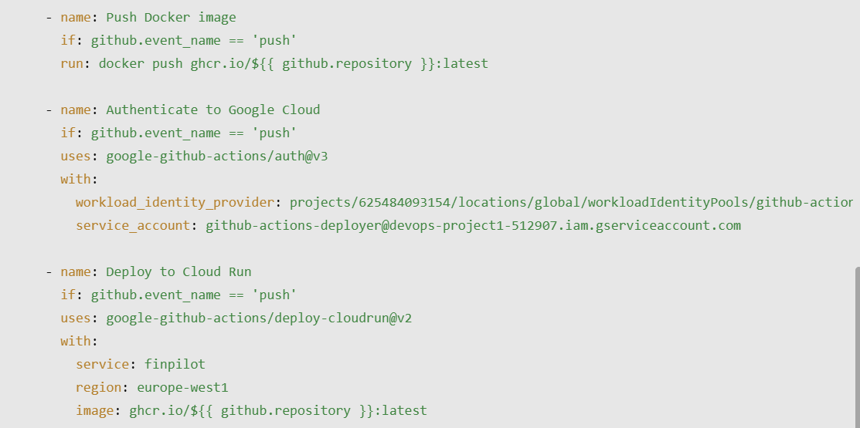
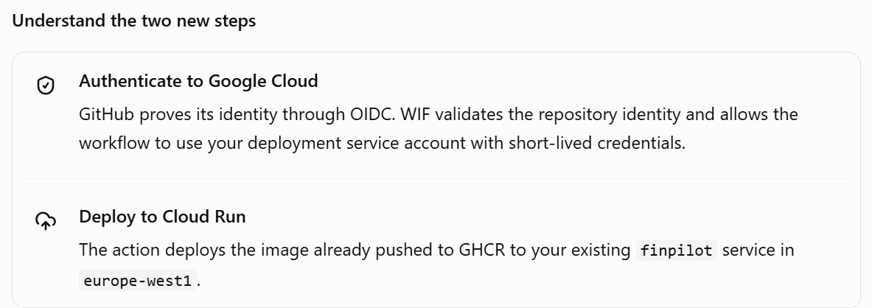
The important new permission is id-token: write. It allows GitHub Actions to request the OIDC token needed for WIF. It does not give the workflow unrestricted access to your Google Cloud project; the provider condition and IAM roles control access.
Step 7 — Save and test
- Commit the updated YAML file to your repository's main branch.
- Open GitHub → your repository → Actions.
- Open the new FinPilot CI and CD run.
- Check that the tests, image push, Google Cloud authentication, and Cloud Run deployment all succeed.
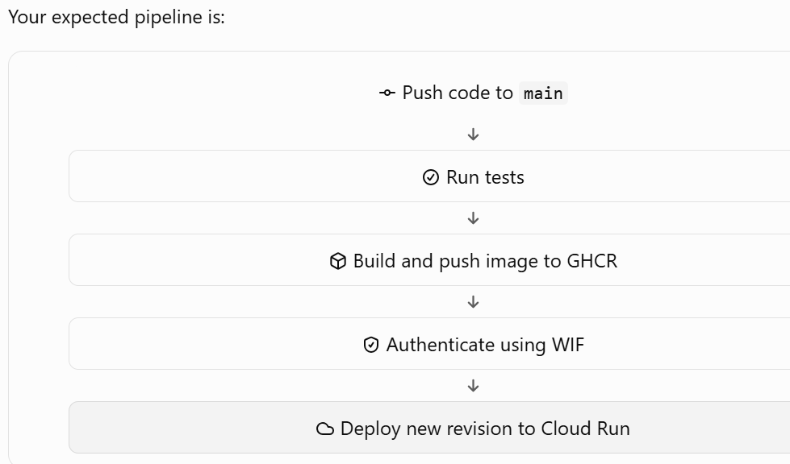
Issues:
provider id is miss-matched with workload identity federation pool and ci.yml file

What's next for your learning?
I recommend this order for FinPilot:
- Test automatic deployment — change a small API response, push to main, and verify that a new revision is created.
- Environment variables and Secret Manager — learn how to configure services without hardcoding sensitive values.
- Logging and monitoring — investigate successful requests, errors, and startup failures.
- Revision rollback and traffic splitting — deploy a new version, send a small percentage of traffic to it, then roll back if necessary.
- Artifact Registry deployment — repeat the pipeline using Google Cloud Artifact Registry instead of GHCR.
Cloud Logging helps you inspect individual events and requests. Cloud Monitoring helps you track trends over time, such as request count, latency, and instance count.
Summarization:
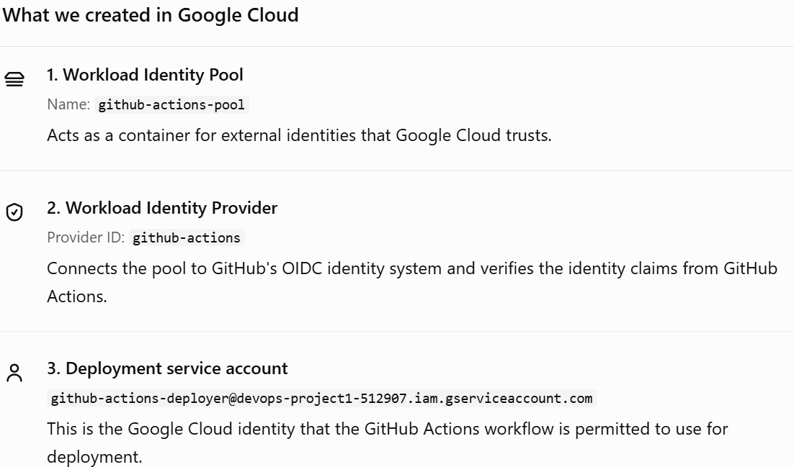
1. Create a workload identify federation pool and provider
pool – container
provider – verify the gituhub action’s identity to openid connect , and validate the github action’s identity
2. Service account: need 3 permissions – 1. Service account user (for application’s runtime service on cloud run) 2. Cloud run admin(to deploy and manage the service) 3. Workload Identity User(to verify the github actions identity vs openid provider)

